How to run the application:

Make sure u have node.js installed. Also need .net8 or above

Firstly open mysql and execute databaseCreation3

Then go to campRatingAppBackend and open it with visual studio

In appsettings.json change the connection string

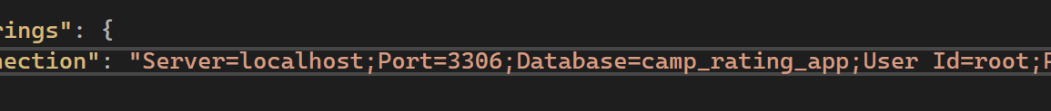

Open \campRatingAppFrontEnd\campRatingAppFrontend in cmd and execute the command

npm run dev

You will see something like this

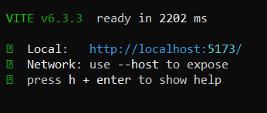

Get this link and paste in in campRatingAppBackend/Program.cs

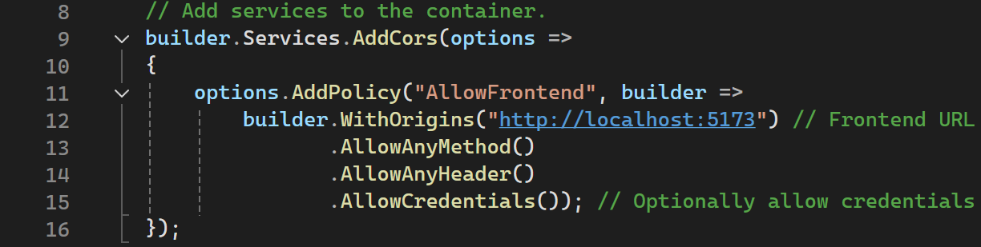

On the place of this url. This ensures that the servers communicate locally since the project isn’t uploaded and is run localy.

Finally go to the link you just pasted in chrome or any browser!